The journey of oat down the digestive system

By Jaishree Charan

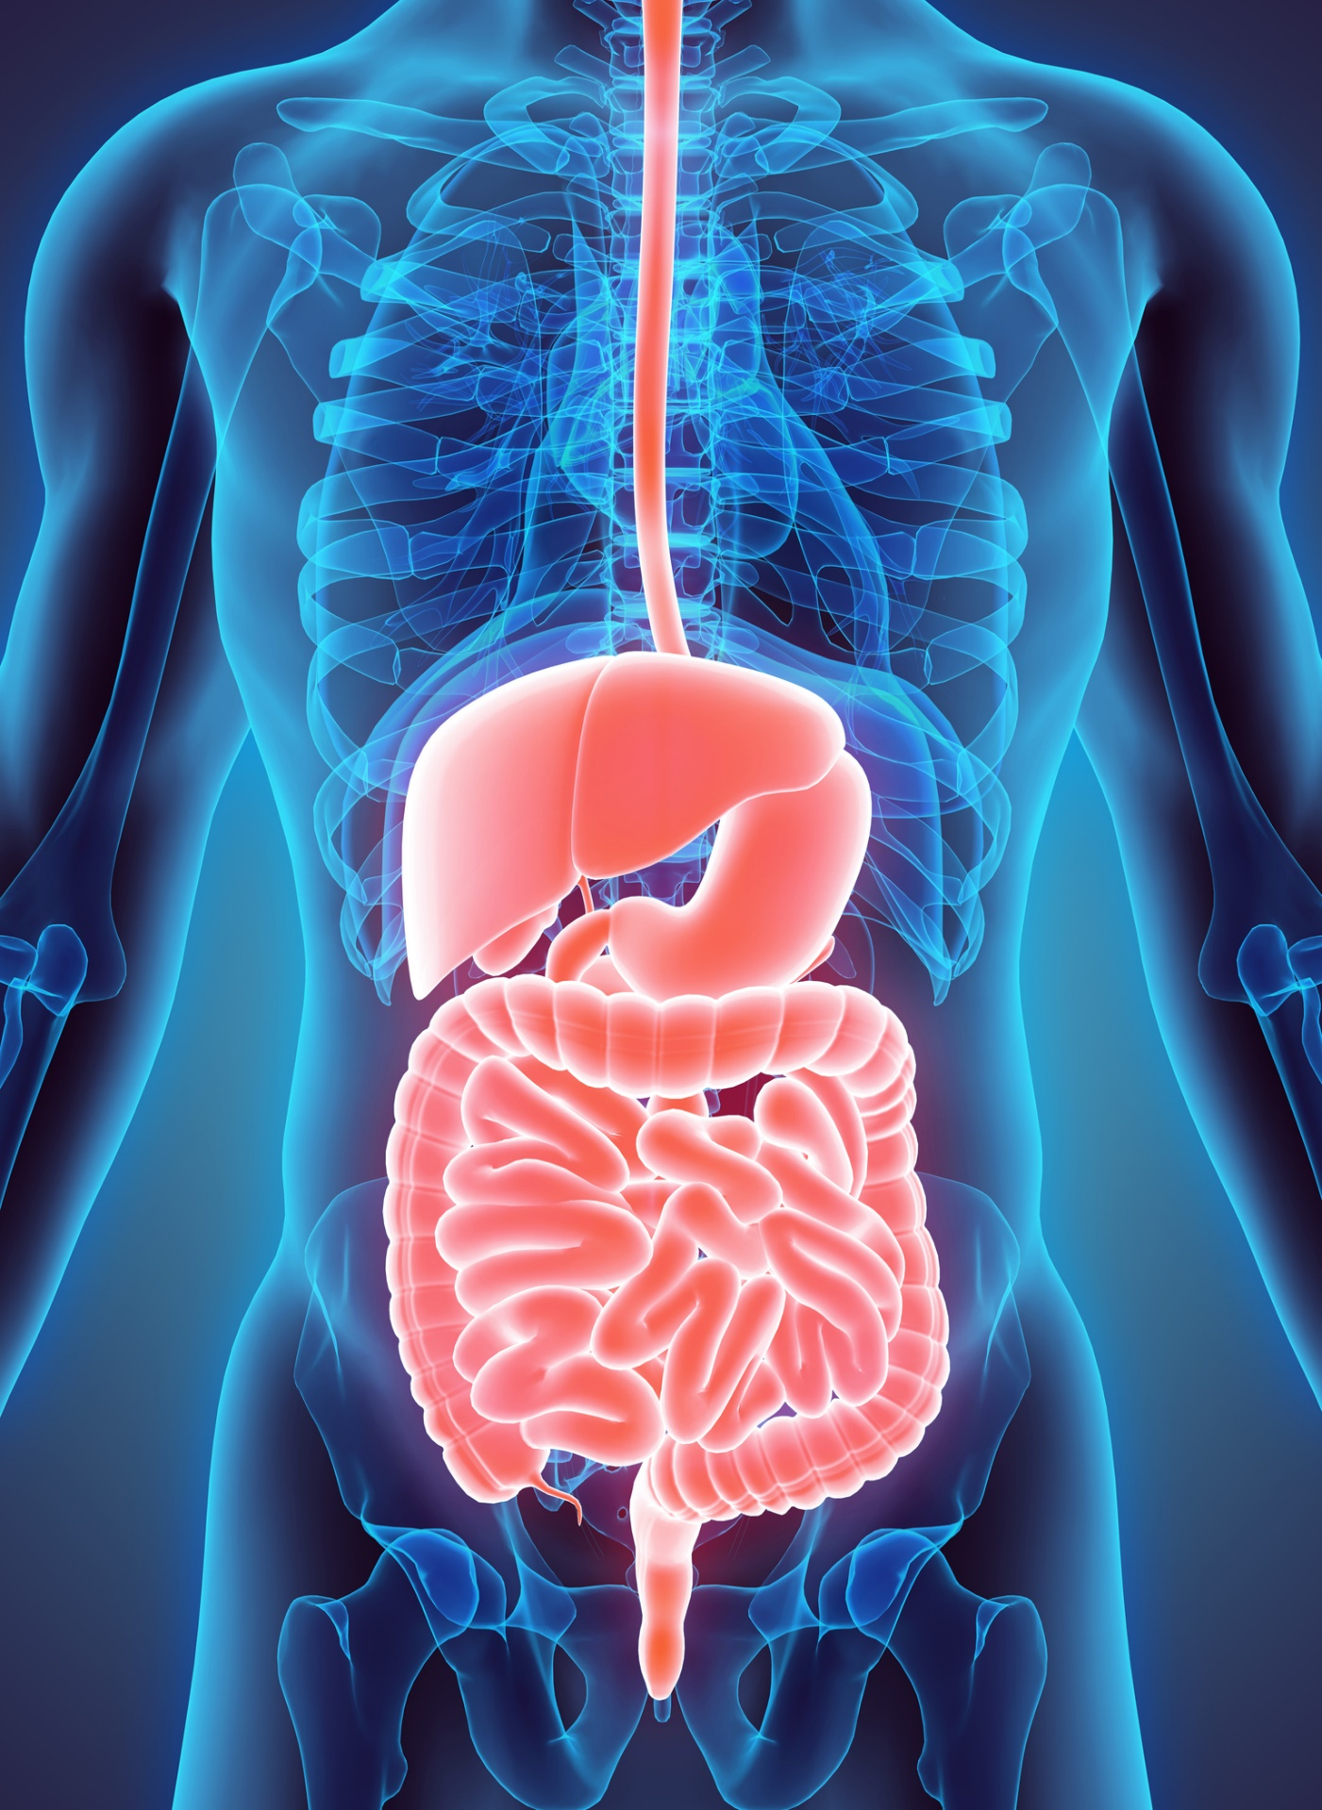

**mouth and Oesophagus**

The mouth is where digestion begins. Here the oatmeal will be mechanically broken-down using teeth, by chewing and grinding motions, in a form that can be easily digested and swallowed by the body. Along with mechanical . the mouth also performs chemical digestion. Saliva from the salivary glands contain enzymes, Catalyst for chemical reactions, which breaks down starches and complex carbohydrate that your body can absorb. The salivary glands rest at the back of the mouth and releases the salivary amylase. After it has been broken down the oats will pass the epiglottis. The epiglottis acts as a barrier between the food and trachea. The oats will travel down the oesophagus to the stomach. The oesophagus is a muscular tube that contracts in a wave like motion as it passes down, this is called peristalsis.

**Stomach -** Describes the role of the stomach in mechanical digestion of food, and if applicable, chemical digestion of proteins

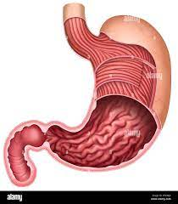The stomach wall contains three layers of smooth muscles, which will contract and churn the oats; this mechanically digests the food and further breaking it down. The stomach contains gastric juices which is a mixture of enzymes and hydrochloric acid allowing the stomach to break down proteins within the oats via chemical digestion. This process turns the remaining partially digested oats into a thick fluid called, chyme. Oats also contain an abundance of lipids, by-products of which can be directly absorbed by the stomach. An enzyme knows as pepsin breaks protein from the oats into small peptides and amino acids that can easily be absorbed in the small intestine. The stomach can absorb water and simple sugars released from the oats. Carbohydrates are not digested chemically within the stomach and is instead passed on to the small intestine for absorption as well. Over all oats and the chyme will spend around six to eight hours in the stomach.

**Small intestine**

**Break down**

the chyme passes from the stomach into the duodenum, the first part of the small intestine, the duodenum breaks down any remaining complex molecules. The presence of certain particles triggers the release of bile and pancreatic juices from the gallbladder and pancreas. Bile emulsifies fats while enzymes digest them. the pancreatic amylase in the pancreatic juice breaks down remaining carbohydrates into glucose and the minerals in the bile help to break down lipids in the duodenum. the chyme then passes into the jejunum and then into the ileum where most of the absorption of nutrients occurs.

**Absorption**

- the main function of the ilium is to absorb vitamin b12, bile salts, and other products of digestion that are not absorbed by the jejunum . (“How does the ileum absorb amino acids? - AskingLot.com”) the internal surface of the ileum is lined with villi. Villi are tine finger -like projection that absorb the nutrients. Micro villi are the layer of cells on the small intestine lining. They are hair like structures that project into the gut lumen, opening inside the bowels, forming a “brush border.” This border absorbs nutrients into the blood stream via capillaries and protect the e body from intestinal bacteria.

**Nutrients used**

As oats is high in carbs it produces an abundance of glucose, which is a major source of energy. Cells also convert glucose into ATP energy through cellular respiration. Similarly, the richness of protein in oats have many benefits. Protein absorption allow protein to be absorbed to make individual building blocks called amino acids. Amino acids help to main taint and improve muscle strength by providing the energy that fuels the muscles contracting during exercising.

Any undigested oats will be passed down to the large intestine for the remaining of the digestion and absorption

**Large intestine**

The large intestine is where the final stage of digestion will occur. The large intestine takes in any indigested waste materials from the chyme where the remaining water is absorbed along with vitamins. The remaining chyme will no longer have much water due to the absorption, giving it a more solid form, also known as faeces. The bacteria in the large intestine will break down any remaining starches releasing vitamins, (vitamin K). The commensal bacteria, provides the host with essential nutrient that is absorbed through the large intestine walls and into the blood stream. Commensal bacteria do this through the process of fermentation, whose by-product are gases released from the large intestine as wind. Commensal bacteria prevent infection and pathogen attacks, as the large intestine produces antibodies to combat commensal bacteria keeping the host safe from potentially dangerous pathogens in waste materials. Foods such as oats will remain in the large intestine for around 36 hours before being passed on to the rectum and anus for the excretion of faeces

Elimination and excretion

This is the final stage the digestive system. The large intestine connects the rectum and send the remaining waste (faeces) to be excreted. The rectum does not have purpose in digestion and instead act as a storage for the faeces until the body chooses to expel it. attaching to the rectum is the naos which act as an opening at the end of the digestive system. Through here faecal matters is defecated to the outside of the body putting an end to the journey of the digestive system.

**References**

*Weiterleitungshinweis*. (n.d.). Google. <https://www.google.com/url?sa=i&amp;url=https://imgbin.com/png/V22U5JzT/small-intestine-large-intestine-gastrointestinal-tract-ileum-digestion-png&amp;psig=AOvVaw14exOaKFsk0LJX1W7N_t_B&amp;ust=1652194947285000&amp;source=images&amp;cd=vfe&amp;ved=0CA0QjhxqFwoTCPCv3_rX0vcCFQAAAAAdAAAAABAI>

N. Jackson, PhD, D. (2022). *How Amino Acids Can Help You Build Strength*. Rn.com. Retrieved 9 May 2022, from <https://www.rn.com/clinical-insights/gastrointestinal-system/>.

*Redirect Notice*. Google.com. (2022). Retrieved 9 May 2022, from <https://www.google.com/url?sa=i&url=https%3A%2F%2Fwww.rn.com%2Fclinical-insights%2Fgastrointestinal-system%2F&psig=AOvVaw3akA1Sna051hKLnpdpMiB-&ust=1652194616894000&source=images&cd=vfe&ved=0CA0QjhxqFwoTCLiI6ODW0vcCFQAAAAAdAAAAABAD>.

Bjarnadottir, A. (2022). *Oats 101: Nutrition Facts and Health Benefits*. Healthline. Retrieved 9 May 2022, from <https://www.healthline.com/nutrition/foods/oats#:~:text=Oats%20are%20rich%20in%20carbs,in%20many%20vitamins%20and%20minerals>.

*What is Protein Absorption, and How is it Beneficial?*. BC30 Probiotics. (2022). Retrieved 9 May 2022, from <https://bc30probiotic.com/idea-center/expert-insight/#:~:text=Protein%20absorption%20refers%20to%20your,maintaining%20and%20improving%20muscle%20strength>.

*Energy for the Cell*. Mandevillehigh.stpsb.org. (2022). Retrieved 9 May 2022, from <http://mandevillehigh.stpsb.org/teachersites/laura_decker/cell_resp_and_photosynthesis_notes.htm>.

*5.4: Digestion and Absorption of Lipids*. Medicine LibreTexts. (2020). Retrieved 9 May 2022, from <https://med.libretexts.org/Bookshelves/Nutrition/Book%3A_An_Introduction_to_Nutrition_(Zimmerman)/05%3A_Lipids/5.04%3A_Digestion_and_Absorption_of_Lipids#:~:text=In%20the%20small%20intestines%20bile,fats%20through%20the%20lymph%20system>.

Rajan, E. (2020). *Digestion: How long does it take?*. Mayo Clinic. Retrieved 9 May 2022, from <https://www.mayoclinic.org/digestive-system/expert-answers/faq-20058340#:~:text=After%20you%20eat%2C%20it%20takes,move%20through%20the%20entire%20colon>.

Heda, R., Toro, F., & Tombazzi, C. R. (2021). Physiology, Pepsin. In *StatPearls*. StatPearls Publishing.

*3.3: Digestion and Absorption of Carbohydrates*. Medicine LibreTexts. (2020). Retrieved 9 May 2022, from <https://med.libretexts.org/Courses/American_Public_University/APUS%3A_An_Introduction_to_Nutrition_(Byerley)/APUS%3A_An_Introduction_to_Nutrition_1st_Edition/03%3A_Carbohydrates/3.03%3A_Digestion_and_Absorption_of_Carbohydrates#:~:text=Carbohydrates%20are%20not%20chemically%20broken,and%20delivered%20to%20the%20liver>.

*How Long Does It Take to Digest Food?*. Healthline. (2022). Retrieved 9 May 2022, from <https://www.healthline.com/health/how-long-does-it-take-to-digest-food#:~:text=Food%20can%20spend%20between%202,hours%20in%20your%20large%20intestine>.

Short, B. (2022). *Microvilli give gut vesicles the brush-off*. Retrieved 9 May 2022, from.

J. Tresca, A. (2021). *Discover What Happens When Lumen Becomes Narrowed*. Verywell Health. Retrieved 9 May 2022, from <https://www.verywellhealth.com/what-is-the-lumen-1942954>.

Lapid, N. (2020). *Your Intestinal Villi Work Hard Absorbing Nutrients From Your Food*. Verywell Health. Retrieved 9 May 2022, from <https://www.verywellhealth.com/understanding-intestinal-villi-562555#:~:text=Intestinal%20villi%20are%20tiny%2C%20finger,1%EF%BB%BF>.

*Digestive System: Function, Organs & Anatomy*. Cleveland Clinic. (2022). Retrieved 9 May 2022, from <https://my.clevelandclinic.org/health/body/7041-digestive-system>.

*Your Digestive System & How it Works | NIDDK*. National Institute of Diabetes and Digestive and Kidney Diseases. (2017). Retrieved 9 May 2022, from <https://www.niddk.nih.gov/health-information/digestive-diseases/digestive-system-how-it-works#:~:text=The%20muscles%20of%20the%20small,digested%20nutrients%20into%20your%20bloodstream>.

# Bibliography

Annigan, J. (2019). *White Bread and Digestion*. Retrieved from Livestrong.com: https://www.livestrong.com/article/520003-white-bread-and-digestion/

Garone, S. (2022, January 13). *How Starch Makes Its Way Through Your Body*. Retrieved from Livestrong.com: https://www.livestrong.com/article/488214-starch-and-digestion/

Newton, T. (2020). *Human Perspectives.* Melbourne: Cengage Learning Australia.

Radhakrishnan, R. (2020, November 12). *What Do Amino Acids Do?* . Retrieved from MedicineNet: https://www.medicinenet.com/what_do_amino_acids_do/article.htm

UPMC. (2022). *Difference Between Small and Large Intestine* . Retrieved from UMPC: https://www.chp.edu/our-services/transplant/intestine/education/about-small-large-intestines